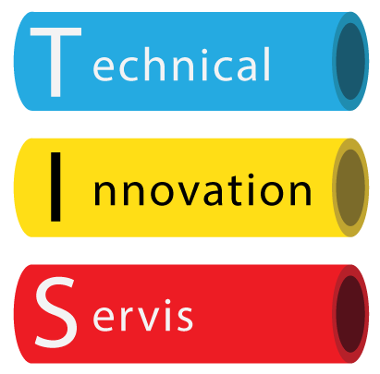
Supporting Learners with additional needs statement

T.I.S and our trainers value the diversity of learners we train and we treat all learners with dignity and respect. We believe every individual should have an equal chance to participate in the course with the goal of passing the training course. We understand each learners needs may be different and to accommodate we can supply the following services. The client can have the written exam read to them. An extra 10 minutes time on each assessment. The written exam is multiple choice to rule out incorrect answers due to spelling etc. Our trainers will ask specific questions during training to ensure candidates understand. Candidates are able to voice record training and make notes in booklets which are given to each candidate. If learning difficulties or requirements are disclosed to trainer we will do all we can to help if practically possible.

